the dangers of intermittent supply as a measure to save water in south Africa

R S Mckenzie

WRP Pty Ltd, PO Box 1522, Brooklyn Square, South Africa 0075, ronniem@wrp.co.za
ABSTRACT
There are many countries around the world where intermittent supply is a way of life and residents often have to deal with a water supply which is only pressurised an hour per day or even an hour per week. Such intermittent water supplies cause huge problems in the long term viability of the water reticulation systems and pose significant health risks.

Here in South Africa, the issue of reducing water losses from municipal water supply systems is becoming a serious problem throughout the country, particularly in view of the current drought situation which is aggravating an already difficult balance between supply and demand. Municipalities throughout the country are being asked to cut their water usage but many of them have neither the expertise nor the funds to implement the appropriate interventions with the result that little progress is being made.

It has become clear that some water suppliers are resorting to the introduction of intermittent supply as a measure to reduce losses and normal water consumption. In some instances, there is clearly no alternative due to the fact that the supply reservoirs are at or near empty. In other cases, the practice of intermittent supply is being used as a quick and simple measure to reduce water losses.

This paper highlights the implications of intermittent supply and the fact that it can be introduced in a matter of hours but the damage caused to the reticulation system may take years to resolve. The paper shows that although some savings can initially be achieved through the introduction of intermittent water supply, in the long-term, such measures will often result in higher water use.

INTRODUCTION
Potable drinking water is becoming one of the most important issues in the 21st century. Growing world population, global warming, improved living standards in many areas and land use changes are among the many factors which exacerbate the impacts of the normal flood and drought events. Climate change is often highlighted as the key factor behind all droughts and floods which often appear more severe than any previously recorded events. While the cause of the more extreme events is often up for some debate, the fact remains that both floods and droughts are becoming more severe and causing huge stress on many regions throughout the world. The situation is unlikely to improve in the foreseeable future and may well deteriorate with the result that water supply managers and other government officials must prepare for more extreme events in future and ensure that the available resources are being used efficiently.

When considering potable water supply, South Africa has many different problem issues to deal with. By global standards, the country has relatively efficient reticulation systems in most of the metros and large municipalities where tap water is generally safe to drink and water is generally supplied at normal first world pressures 24 hours a day. While this is often taken for granted in many parts of South Africa, it is unusual in most parts of the developing world. In many of the rural areas in South Africa, safe drinking water cannot be taken for granted and such areas regularly experience severe supply problems during times of drought. Such local water supply schemes are extremely vulnerable to drought events due to the fact that they often rely on run-of-river flow or groundwater for their water supply. Such small local schemes lack the assurance of supply provided by the large integrated water supply systems used to supply the urban areas where reservoirs are often linked to each other across provincial boundaries to provide a reliable supply that can withstand droughts of 5 or even 10 years in duration. In effect, rural water supply schemes will tend to experience regular but shorter drought events while the large interbasin schemes will experience less frequent but potentially much longer drought events.

The above points are well illustrated by some facts and figures which were recently presented by the Department of Water and Sanitation (DWS, 2016) to highlight the water situation in the Vaal River System which supplies the main industrial heartland of South Africa including the whole of Gauteng, many mines, power stations, large industries etc. Error: Reference source not found provides a graph showing the percentage storage in the major reservoirs which supply the Vaal River System (based on information from DWS, 2016). The actual storages in each of the main reservoirs in the system as on 1 May 2016 are provided in Table 1.
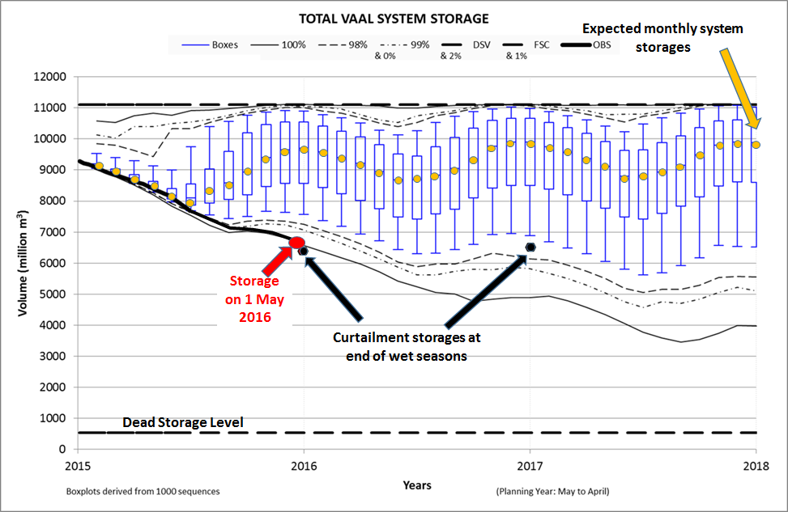
Figure 1: Storage status of Vaal River System at end of 2015/16 Wet Season (DWS, 2016)

Table 1: Reservoir storages for Vaal River System
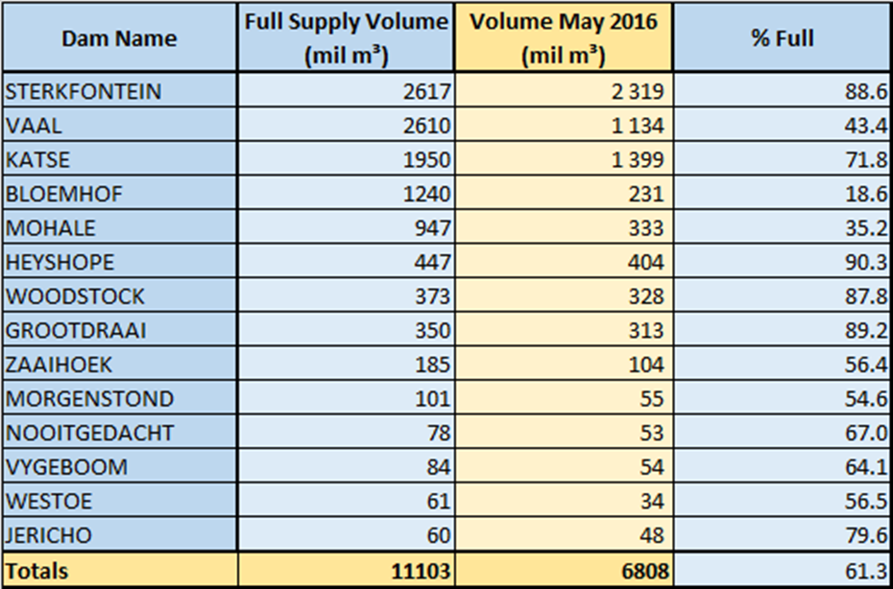

As can be seen from the figures, the major reservoirs in the Vaal River System at the end of the 2016/16 wet season were around 60% full. In most countries around the world, this would not be considered to be a major concern. However, in the South African context, it is considered to be a significant risk and is very close to the level at which restrictions are considered. In order to operate and manage its water resource systems, the Department of Water and Sanitation (DWS) utilises what is widely recognised as one of the most sophisticated water resource models in the world. Rather than waiting for the situation to deteriorate to the extent that has recently been seen in many other countries around the world, the DWS tries to introduce drought restriction measures as early into a drought event as can be identified. The policy of introducing restrictions early in the drought, helps to avoid the introduction of the most severe restrictions which can have a serious and detrimental effect on the economy. In many cases, less severe restrictions applied early in a drought will be sufficient to avoid severe restrictions as has been demonstrated in the Vaal River System over the past 35 years during which only light restrictions have ever been applied.

INTERMITTENT WATER SUPPLY
Intermittent water supply is the practice of cutting off the water supply into an area at certain times of the day. Typically, it is used to reduce water consumption in an area by cutting off the supply during the night-time when consumers are asleep and not using water. In such cases the water supply is cut from approximately 8pm to 5 am which will normally be achieved by manual closing of valves or through the use of electronic devices which can be programmed to open or close the valves at specific times of the day.

Intermittent supply is usually introduced either as an emergency measure, when the supply reservoir is close to , empty or in other cases as a measure to control water use and reduce wastage. In the first case when there is little water left in the supply reservoir, there may be no alternative to the rationing of water and an intermittent supply cannot be avoided once the supply resource has been depleted. In the second case, where the intermittent supply is introduced as a water saving measure, however, there may well be alternative interventions that can provide savings without some of the problems that tend to accompany such pressurising and depressurising of the system. In South Africa, many municipalities are currently considering intermittent supply as a semi-permanent water saving measure. The remainder of this paper addresses some of the important issues that should be taken into account when introducing such measures.

HEALTH ISSUES
Before looking at the actual water savings that can be achieved through intermittent supply, it is important to recognise the potential health risks associated with such practice.

Figure 2 provides a simplified layout of the water supply to a property which has either water borne sewage or a basic septic tank system. In this example, the sewer network is shown to be leaking with the result that there is some level of sewage contamination in the ground surrounding the water supply pipes. Under normal conditions, the water supply is fully pressurised and therefore any leakage from the water supply network is effectively clean water leaving the pipes and mixing with the surrounding groundwater which may or may not be contaminated. As long as the system remains pressurised there is minimal opportunity for the water supply to the property to be contaminated in any way.

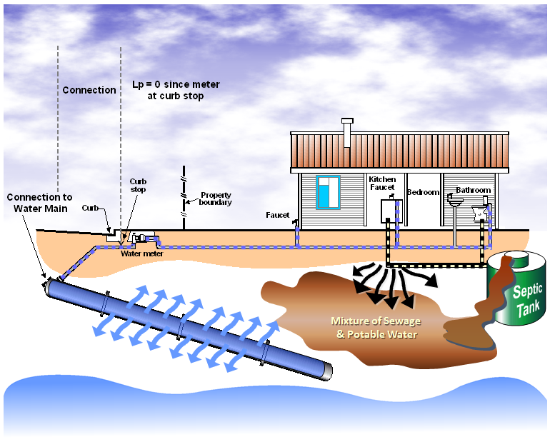
Figure 2: Typical water supply to a property when pressurised

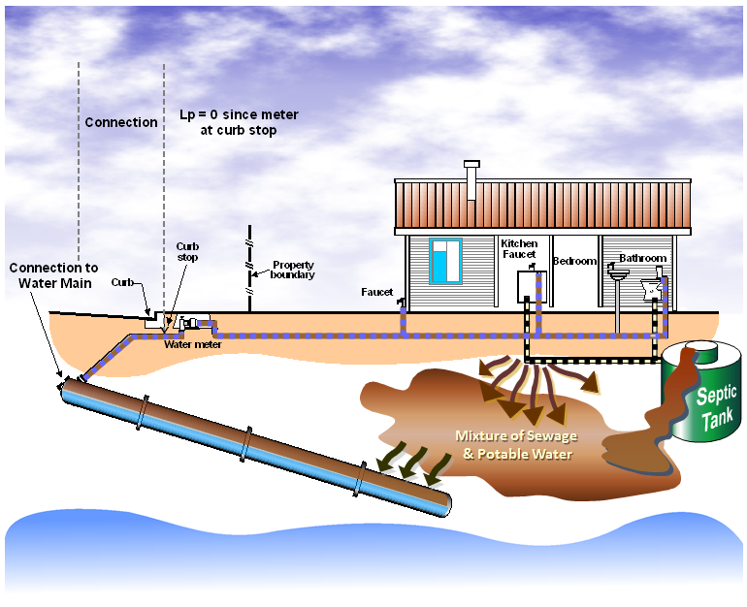
Figure 3: Water supply contamination when system is depressurised.

In the event that the water supply system is depressurised as shown in Figure 3, there is a possibility for the groundwater surrounding the water supply pipe to enter the supply since any leaks in the pipeline can allow water to move in either direction. If the groundwater surrounding the pipes is contaminated in any way, there is a risk that contaminated water will be supplied to the property when the system is re-pressurised as shown in Figure 4.

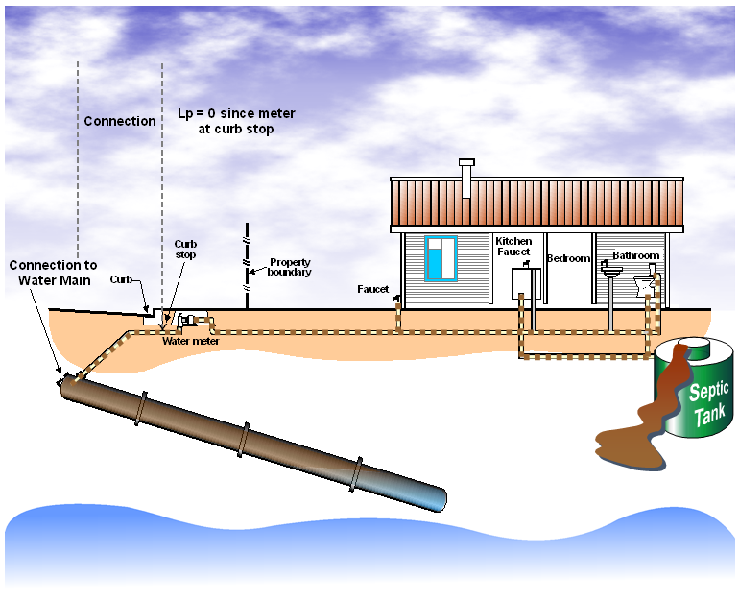
Figure 4: Contaminated water supplied to property when re-pressurised.

The above figures highlight the potential health risks associated with intermittent supply which can result in certain water borne diseases in cases where there is insufficient chlorine in the potable water to neutralise the contaminants. In such cases, typhoid and cholera can occur.

REDUCING CONSUMPTION THROUGH INTERMITTENT SUPPLY
The main purpose of introducing intermittent supply is to reduce water consumption. Figure 5 depicts a graph of the flow into a residential area in South Africa in which intermittent supply has been introduced by the municipality.

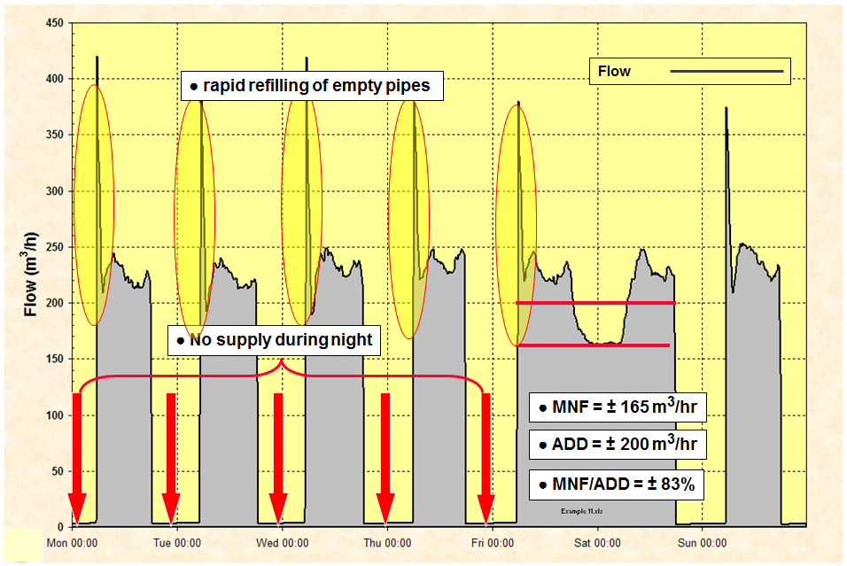
Figure 5: Typical flow logging for a zone with intermittent supply

This is an interesting and informative logging result from an area which was experiencing high levels of household leakage. In order to save water, the municipality adopted a water supply regime of 12 hours on and 12 hours off. In order to assess the level of leakage, the water supplier was asked to maintain the system pressurised for 2 days in order to observe and measure the Minimum Night Flow (MNF) (see WRC, 1999) which was estimated to be 165 m³/hr. Over the same 2 day period, the Average Daily Demand (ADD) was measured to be 200 m³/hr. In such cases, the ratio of the minimum night flow to the average daily demand (MNF/ADD) is a useful indicator of leakage in the area. In this case the MNF/ADD ratio was found to be 0.83 or over 80%. While this calculation is not always a reliable indicator (since not all of the nightflow is leakage), it is generally a useful indicator in areas experiencing high levels of leakage. Typically a system with little leakage will have a ratio of around 0.1 to 0.2 and anything higher will suggest some form of leakage problem. In South African systems, any ratio above 0.2 is considered to be an indication of high leakage and any ratio above 0.5 will usually reflect high internal household leakage. Figures in excess of 0.9 have been observed in some areas.

Another interesting issue that can be seen in Figure 5 is the refilling spike that occurs each morning when the system is re-pressurised. This spike in flow is caused by the initial volume of water required to fill the empty pipes after a period of zero water pressure. Such sudden and extreme high flow rates can damage the water meter if the peak flow exceeds the upper limit of the meter. In addition to the refilling spike, there is also the problem of air in the pipeline which must escape somewhere and if the air-valves on the pipeline are not functional, the air will create problems either on the reticulation or in the consumer properties. If intermittent supply is continued for lengthy period (years), the leakage rates in the reticulation system will increase to such an extent that the system will eventually break down completely.

Figure 6 shows an example where a water supplier decides to introduce intermittent supply for 10 hours each night between 8pm and 6am. The average daily consumption to the area drops from 17.4 m³/hr to 14.0 m³/hr which represents a reduction of approximately 20% for a 40% reduction in time pressurised. In this example, the leakage is already very high and yet the benefit achieved is relatively modest. In an area with low leakage, the benefit will be significantly smaller and leads to the question of whether or not such a measure is worthwhile.

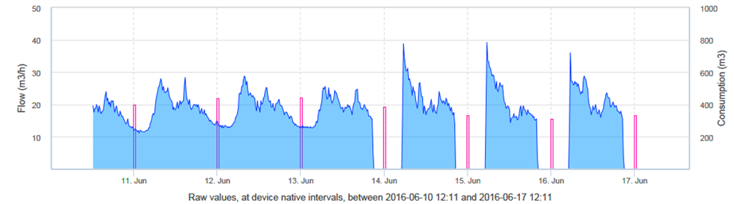
Figure 6: Water savings through intermittent supply

Recent research undertaken internationally (Charalambous, 2016) also raises questions regarding the water saving benefits of introducing intermittent supply. On a large scale project undertaken in Cyprus, Charalambous observed the following:
- Over 1/3 of water supply systems in Africa operate on intermittent supply;
- Intermittent supply had a detrimental effect on the integrity of the distribution network;
- In a specific case study, intermittent supply resulted in a 200% increase in mains bursts and a 100% increase in service connection bursts;
- Intermittent supply created water quality problems;
- Intermittent supply caused customer dissatisfaction;
- In the case study, the total water supply initially dropped after introducing intermittent supply but within 3 years had increases to pre- intermittent supply levels thus eliminating any savings;
- Intermittent supply is not an appropriate response to drought / water shortage

To place the issue in perspective, Figure 7 shows the difference that can be expected between intermittent supply and continuous supply in a zone. Obviously to achieve 24/7 pressurised supply after a period of prolonged intermittent supply will require significant effort and investment due to the damage caused to the network by the destructive action of pressurising and depressurising the system.
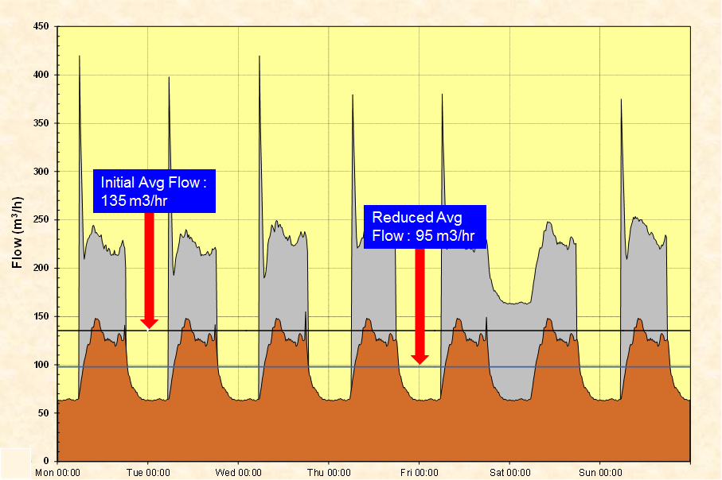
Figure 7: Intermittent supply compared to pressurised supply

The example shown in Figure 7 is based on what can be achieved if the system leaks are repaired and the pressure is used as a management tool. As can be seen, the average water use by the zone is 135 m³/hr when operating under intermittent supply and 95 m³/hr when operating under 24/7 pressurised supply. While the figures will naturally change from system to system, the underlying message is clear – intermittent supply will eventually result in greater water use than 24/7 pressurised supply, assuming that the resource is capable of supporting the demand from the system.

CONCLUSIONS
Based on real results from systems around the world the following conclusions can be drawn with regard to the use of intermittent supply when used as an intervention by municipalities to save water:
- Intermittent supply is considered by many municipalities to be a quick and easy intervention for reducing water use in an area;
- Intermittent supply will result in a short-term reduction in water use but this is likely to be offset by increased leakage in the long-term, resulting in an overall increase in water use;
- Intermittent supply damages the water reticulation network and increases the number of bursts;
- Intermittent supply can create water quality problems and in some cases increase the incidence of water related diseases such as typhoid and cholera;
- Implementing intermittent supply can be achieved in a matter of hours while returning to a reliable 24/7 pressurised supply can take years due to the damage caused to the network;
- Water service providers that have resorted to intermittent supply have major governance and incentive flaws and need in-depth reform. Moving to continuous supply requires often very difficult political and institutional choices that many governments prove reluctant to make. A paradigm shift is imperative (Charalambous, 2016).
- Intermittent supply is not an appropriate long-term intervention for reducing water use or water losses.

RECOMMENDATIONS
- Water service providers should implement water saving measures (WRC, 2014) and/or restrictions early on in a drought to avoid having to take emergency measures when water supplies can no longer support the demands;
- Reducing water pressures to below the acceptable norms in order to maintain a 24/7 pressurised supply is preferable to introducing an intermittent supply. Liaison with the fire department will be helpful in such cases to address liability and insurance issues;
- Properly sectorised networks with clearly defined and controlled pressure zones have the added benefit that pressure can be used to control water use during severe droughts. Water service providers should therefore be encouraged to set up and operate such zones during normal operating conditions so that the necessary infrastructure is in place when needed.
- Intermittent supply should be the option of last resort and not the option of first choice;

REFERENCES
Charalambous, B. 2016. Intermittent Water Supply in Water Distribution Networks. Paper presented at Water Loss 2016, the IWA Biennial Conference on Water Losses held at
the Lalit Ashok Hotel in Bangalore, India. 31 Jan to 3 Feb 2016.

DWS, 2016. Development of Annual Operating Rules for the Integrated Vaal River System (IVRS):May 2016

WRC, 1999. Development of a standardised approach to evaluate bursts and background losses in water distribution systems in South Africa: SANFLOW. Report TT109/99, by R Mckenzie to the South African Water Research Commission, June 1999. ISBN No. 1 86845 490 8

WRC, 2014. Guidelines for Reducing Water Losses in South African Municipalities Report TT 595/14 by R Mckenzie to the Water Research Commission, ISBN 978-1-4312-0565-3, August 2014

ABOUT THE AUTHOR
Ronnie is a specialist in Water Demand Management, Hydrology, Water Resource Planning, Management and Operation, with more than 25 years of experience in these fields. He has been involved in the analysis of many water resource systems in the Republic of South Africa and elsewhere in Southern Africa. Since 1994, Ronnie has helped to introduce the Burst and Background Estimate (BABE) procedures to South Africa. He developed and introduced new Leakage Benchmarking software which is now used throughout South Africa and has been modified for use in many other countries including Thailand, India, Australia and New Zealand. He has developed many new models through the Water Research Commission to assist water suppliers in managing their leakage and has pioneered the use of Advanced Pressure Control throughout South Africa and several other countries. Ronnie initiated and helped to manage the Khayelitsha Pressure Management installation in Cape Town as well as the Sebokeng/Evaton Public Private Partnership, both of which won several national awards (SAICE, IMESA and SAACE) for technical excellence and are two of the largest advanced pressure control installations in the world. He has organised and/or presented at more than 100 workshops on pressure management and WDM in many countries including South Africa, USA, Ethiopia, New Zealand, Australia and the UK. He currently provides specialist WDM support to various organisations including the World Bank, the EU, UN , MWA of Thailand and is the current Chairman of the International Water Association’s Water Loss Specialist Group.

